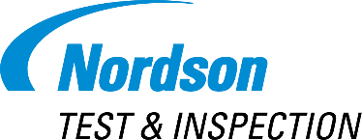

Nordson TEST & INSPECTION Features Quadra 7 Pro MXI System at SEMICON West 2023

Aylesbury, United Kingdom — June 2023 — Nordson TEST & INSPECTION today announced that it will highlight the new Quadra 7 Pro Manual X-ray Inspection (MXI) System and demonstrate the WaferSense® Auto Teaching System™ (ATS2) at SEMICON West. The highly anticipated Quadra 7 Pro will be the talk of booth 964 during the event, which is scheduled to take place from July 12-14, 2023, at the Moscone Center in San Francisco, California.

The Quadra 7 Pro MXI system sets a new standard for 3D/2D manual inspection with a higher resolution for back-end semiconductor applications. Equipped with the revolutionary Onyx® detector technology, it delivers exceptional image clarity and reduced noise levels, elevating the inspection experience to unprecedented levels of accuracy and efficiency.

The Quadra 7 Pro is equipped with the latest Dual Mode Quadra NT4® tube, which provides users with maximum flexibility. This innovative feature offers brightness and resolution modes, allowing operators to dynamically switch between them based on their specific application requirements.

In addition to its advanced hardware, the Quadra 7 Pro is complemented by the newly developed Revalution™ software. Designed specifically for high-end semiconductor applications, Revalution™ software enhances the user experience with an intuitive interface, optimized workflow, and expanded functionality. It enables operators to efficiently analyze and interpret inspection data, contributing to faster decision-making and improved overall productivity.

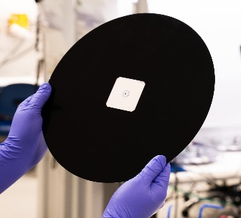
The WaferSense® ATS2 multi camera sensor is used with CyberSpectrum™ software to teach accurate wafer hand-off calibration for proper alignment and set-up of semiconductor tools. The sensor can "see" inside to capture three dimensional off-set data (x, y and z) in real-time to quickly teach wafer positions - all without opening the tools. Process and equipment engineers can conduct repeatable and reproducible setups and maintenance checks, speed trouble-shooting and eliminate technician-to-technician variation. Semiconductor Fabs worldwide significantly improve their yields, processes and productivity with WaferSense sensors.

Visit booth 964 at SEMICON West to experience the Quadra 7 Pro Manual X-ray Inspection system firsthand and witness the future of advanced inspection technology.

For more information, visit www.nordson.com.

About Nordson TEST & INSPECTION
Nordson TEST & INSPECTION offers its customers a robust product portfolio, including Acoustic, Optical and Manual X-ray Inspection, Autonomous X-ray Inspection, X-ray Component Counting and Nordson X-ray Technologies. Nordson TEST & INSPECTION is uniquely positioned to serve its customers with best-in-class precision technologies, passionate sales and support teams, global reach, and unmatched consultative applications expertise.

About Nordson
Nordson Corporation (Nasdaq: NDSN) is an innovative precision technology company that leverages a scalable growth framework through an entrepreneurial, division-led organization to deliver top tier growth with leading margins and returns. The Company’s direct sales model and applications expertise serves global customers through a wide variety of critical applications. Its diverse end market exposure includes consumer non-durable, medical, electronics and industrial end markets. Founded in 1954 and headquartered in Westlake, Ohio, the Company has operations and support offices in over 35 countries. Visit Nordson on the web at www.nordson.com, www.twitter.com/Nordson_Corp or www.facebook.com/nordson.

For additional information, contact:

Carla Furanna
Nordson Test & Inspection
952-820-5837

